## TABLE DESIGN

## Collection 1

**Collection name: userDetails**

|  |  |  |  |
| --- | --- | --- | --- |
| **S. No** | **Fields** | **Data type** | **Description** |
| 1 | name | String | Name of the user |
| 2 | email | String | Email |
| 3 | address | String | Address of the user |
| 4 | phone | String | Phone number of the user |
| 5 | profilepicURL | String | Profile image of the user |
| 6 | role | String | The type/role of user |
| 7 | status | String | User’s Status |
| 8 | rating | Number | Rating of the driver |
| 9 | aadhaar | String | Aadhaar uploaded by driver/car owner |
| 10 | license | String | License uploaded by driver/car owner |

user

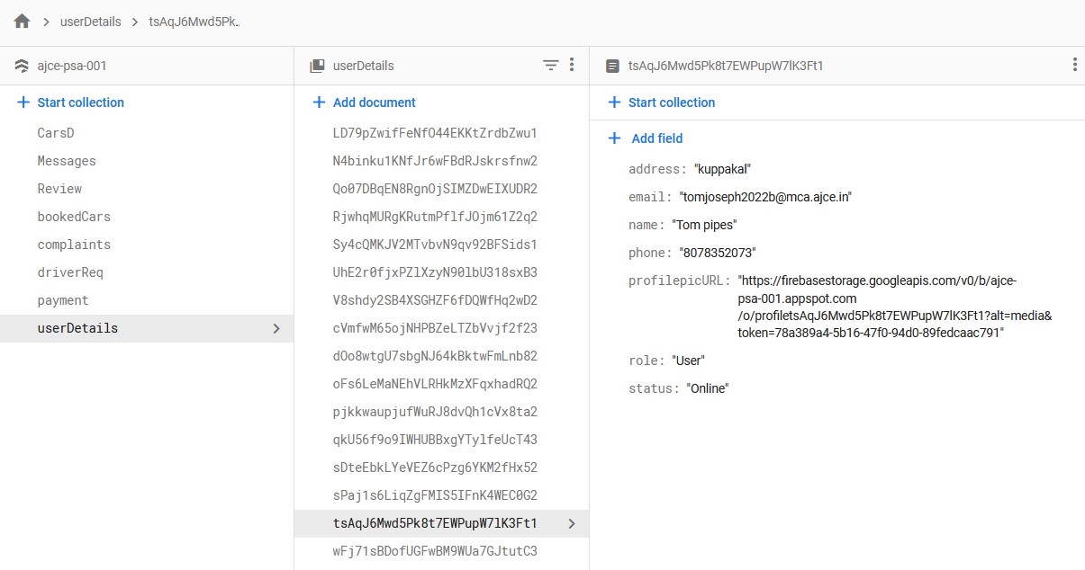

Car owner

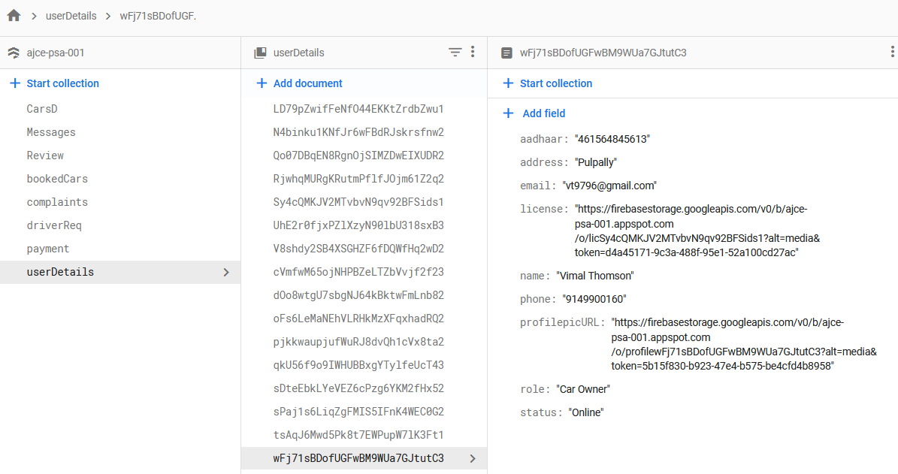

Admin

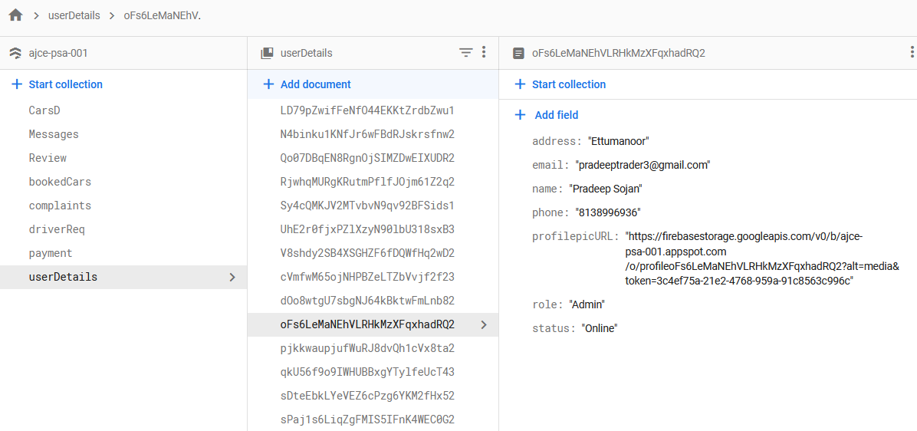

Driver

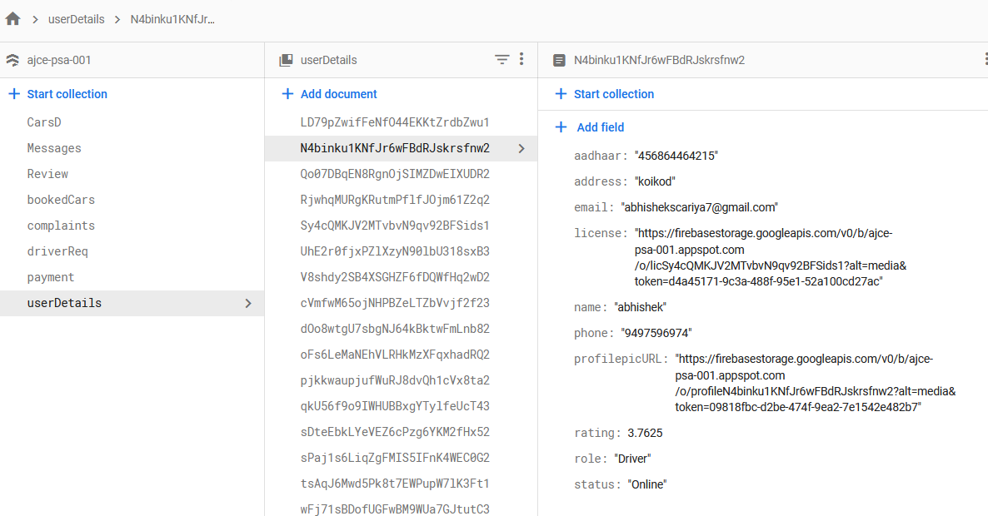

**Collection 2**

**Collection name: complaints**

|  |  |  |  |
| --- | --- | --- | --- |
| **S.No** | **Fields** | **Data type** | **Description** |
| 1 | Complaint | String | Complaints written by the users |
| 2 | useremail | String | Name of the user who has given the complaint |
| 3 | Driver Name | String | Name of the driver who the user has complaint about. |
| 4 | Driver Email | String | Email of the said driver |
| 5 | status | String | Status of the complaint |
| 6 | date | timestamp | Time the complaint was made. |

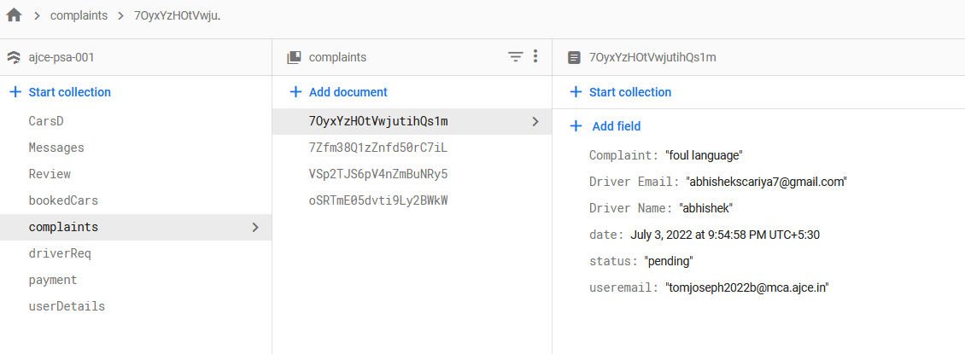

**Collection 3**

**Collection name : bookedCars**

|  |  |  |  |
| --- | --- | --- | --- |
| **S.No** | **Fields** | **Data type** | **Description** |
| 1 | car | String | Name of the booked car |
| 2 | car id | String | Id of the booked car |
| 3 | coid | String | Id of the carowner whose car is booked |
| 4 | color | String | Color of the car |
| 5 | brand | String | Brand of the booked car |
| 6 | fuel | String | Fuel type of the car |
| 7 | gear | String | No of gears in the car |
| 8 | path | String | Image of the booked car |
| 9 | name | String | Name of the user who booked the car |
| 10 | email | String | Email of the user who booked the car |
| 11 | phone | String | Phone number of the user |
| 12 | price_pd | Number | Price of the car per day |
| 13 | fromdate | String | Date from which the car is booked |
| 14 | todate | String | Date to which the car is booked |
| 15 | date | String | Date of the booking |
| 16 | address | String | Address of the user |
| 17 | status | String | Status of the booking |

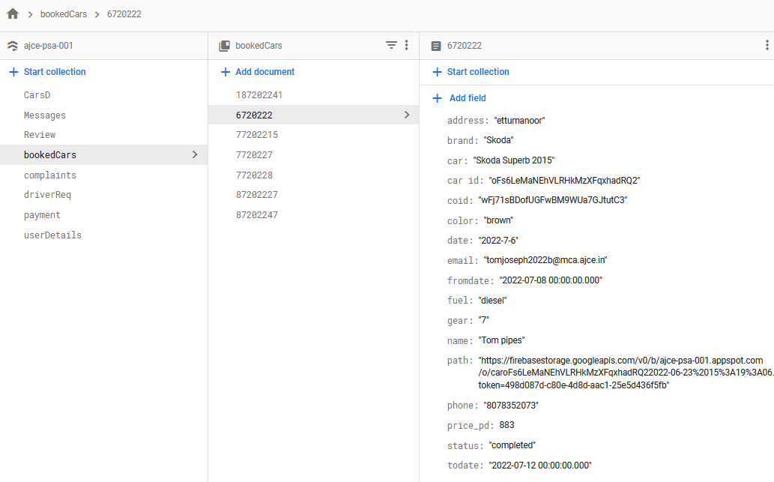

**Collection 4**

**Collection name : CarsD**

|  |  |  |  |
| --- | --- | --- | --- |
| **S.No** | **Fields** | **Data type** | **description** |
| 1 | name | String | Name of the car |
| 2 | brand | String | Brand of the car |
| 3 | color | String | Color of the car |
| 4 | coid | String | Id of the car owner |
| 5 | fuel | String | Fuel type of the car |
| 6 | gear | String | No of gears in car |
| 7 | path | String | Image of the car |
| 8 | price | String | Monthly price of the car |
| 9 | status | String | Status of the car |

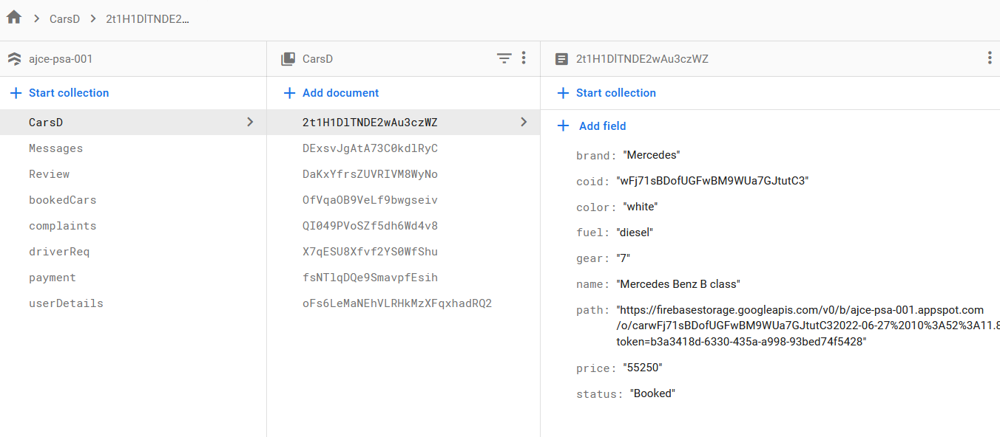

**Collection 5**

**Collection name : driverReq**

|  |  |  |  |
| --- | --- | --- | --- |
| **S.No** | **Fields** | **Data type** | **Description** |
| 1 | user email | String | Email of the user |
| 2 | user name | String | Name of the user who requested for driver |
| 3 | user phone | String | Phone no of the user |
| 4 | suggestions | String | Suggestions of the user |
| 5 | location | String | Address of the user |
| 6 | fromdate | String | Date from which driver is required |
| 7 | todate | String | Date to which driver is required |
| 8 | Req date | String | Date at which request is made |
| 9 | driver_name | String | Name of the driver who took the job |
| 10 | driver_id | String | Id of the driver |
| 11 | driver_email | String | Email address of the driver |
| 12 | driver_phone | String | Phone no of the driver |
| 13 | completed_date | String | Date at which request is completed |
| 14 | status | String | Status of the request |

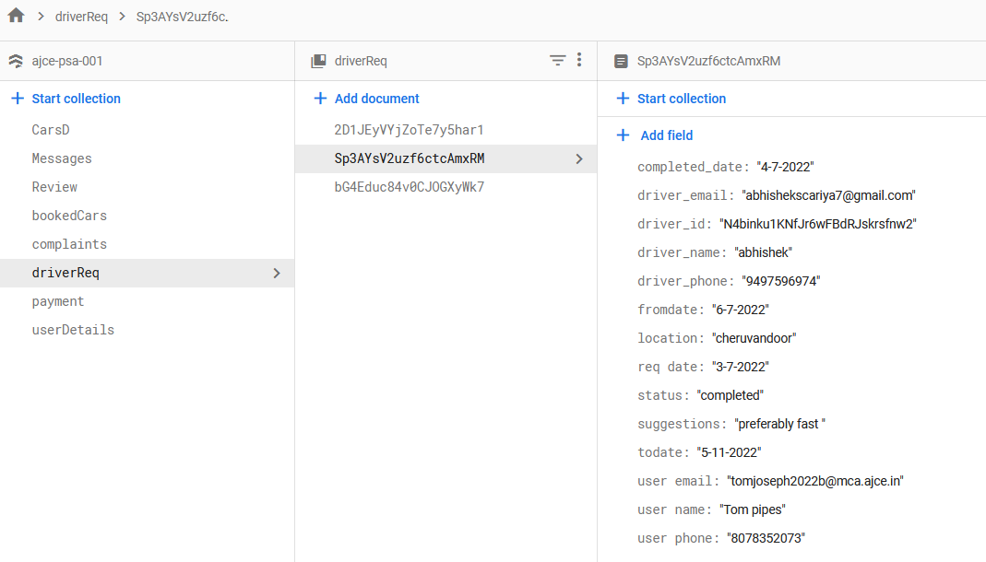

**Collection 6**

**Collection name : payment**

|  |  |  |  |
| --- | --- | --- | --- |
| **S.No** | **Fields** | **Data type** | **Description** |
| 1 | email | String | Email of the user |
| 2 | name | String | Name of the user who requested for driver |
| 3 | phone | String | Phone no of the user |
| 4 | car | String | Name of the car |
| 5 | address | String | Address of the user |
| 6 | fromdate | String | Date from which car is booked |
| 7 | todate | String | Date to which car is booked |
| 8 | date | String | Date at which car is booked |
| 9 | price per day | number | Price of the car per day |
| 10 | car_id | String | Id of the car |
| 11 | coid | String | Id of the car owner |
| 12 | carrate | number | Rate of the car depending on the no of days car is booked |
| 13 | additional_costs | number | Additional costs |
| 14 | totalrate | number | Total rate of car |
| 15 | admincost | number | Set percentage that is given to the admin |
| 16 | overallcosts | number | Overall cost of the booking |
| 17 | path | String | Image of the car |
| 18 | status | String | Status of the payment |

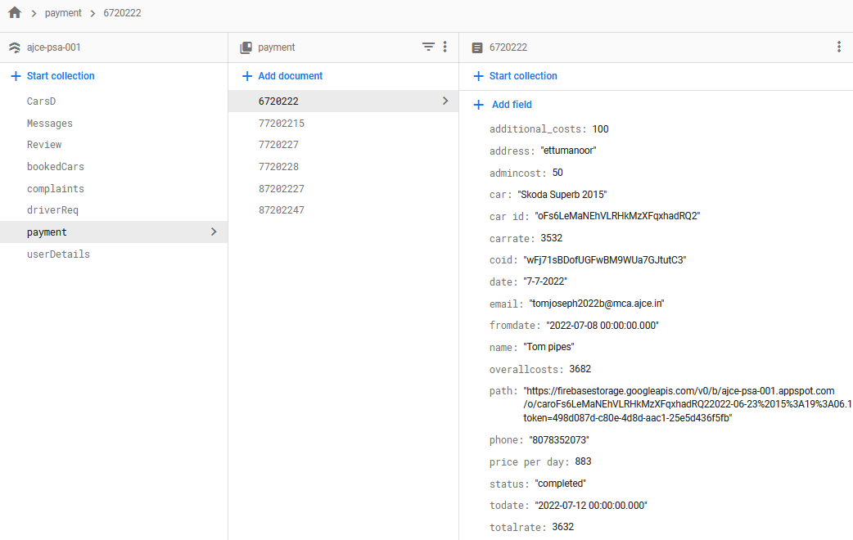

**Collection 7**

**Collection name : Review**

|  |  |  |  |
| --- | --- | --- | --- |
| **S.No** | **Fields** | **Data type** | **Description** |
| 1 | User Name | String | Name of the user |
| 2 | User email | String | Email of the user |
| 3 | suggestions | String | Suggestions of the user |
| 4 | date | timestamp | Date of the review |
| 5 | price_rating | number | Price rating of the user |
| 6 | service_rating | number | Service rating of the user |
| 7 | overall_rating | number | Overall rating of the user |

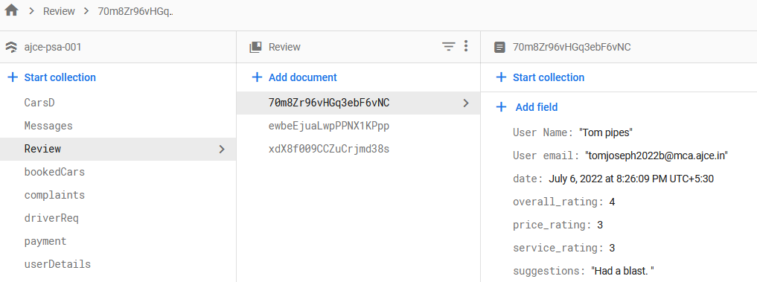

**Collection 8**

**Collection name : messages**

|  |  |  |  |
| --- | --- | --- | --- |
| **S.No** | **Fields** | **Data type** | **Description** |
| 1 | message | String | Messages written by the user |
| 2 | email | String | Email of the user |
| 3 | time | timestamp | Time of the message |

